Welcome to
Lincoln Elementary Community School

STUDENT HANDBOOK 2023-2024



Mrs. Susanna Withers Mrs. Fern Touchie
Administrative Assistant Principal

2475 Lincoln Road, Rte 102 Hwy
Lincoln, NB E3B 7E6
Telephone: (506) 357-4075

Fax: (506) 446-9437
District Home page: http://www.asd-w.nbed.nb.ca
Anglophone West School District: 1-888-388-4455
School Website: http://lincoln.nbed.nb.ca
Twitter: @LincolnLion2021
Instagram: @lincolnlions2021

SCHOOL CALENDAR – PUBLIC

2023-2024

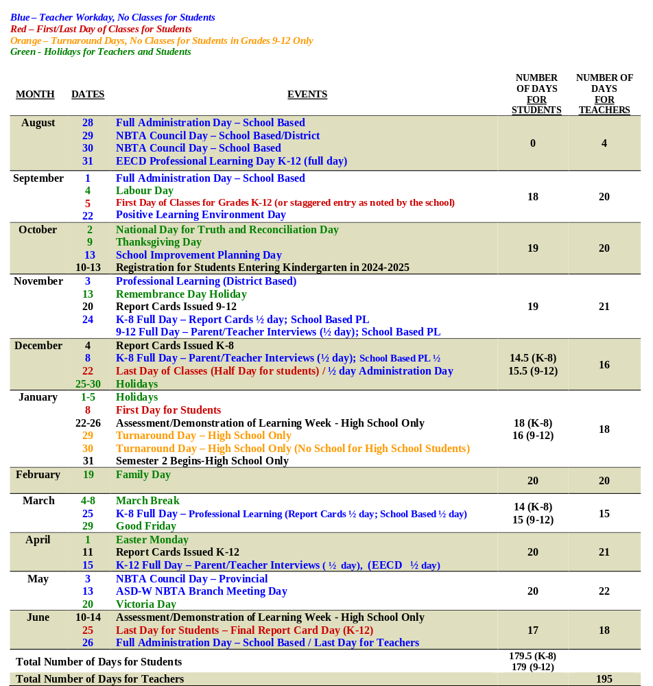

HOURS OF INSTRUCTION

**Our school opens at 7:40 am and supervision for students begins at this time, upon the arrival of the first bus. Students may not be dropped off at the school prior to 7:40am.**

Monday, Tuesday, Wednesday and Thursday
7:55 am Entrance Bell
8:00 am Classes begin
10:00 am- 10:20 am Morning Recess K-5
11:50 am-12:30 pm Recess/Lunch K-5
1:30 pm K-2 Dismissal
2:30 pm 3-5 Dismissal

*Dismissal on Fridays is 11:30 am for all students in K-5.

Lincoln Elementary Community School Vision

Every child will leave Lincoln Elementary Community School having acquired skills and competencies to become a lifelong learner and a respectful, well-rounded, healthy citizen.

School Mission

Through student engaged learning and CARE education, our students will value their academic progress and growth towards becoming well-rounded and resilient individuals. Our positive school environment respects and values diversity and promotes a balance of academic achievement and wellness.

EDUCATION ACT

The Education Act for the Province of New Brunswick states:

Roles of Parents Duties of Pupils

13(1) In support of the learning success of his/ her child and the learning environment at the school, a parent is expected to:
- encourage his or her child to attend to assigned homework,
- communicate reasonably with school personnel employed at the school his or her child attends as required in the best interests of the child,
- cause his or her child to attend school as required by this act,
- ensure the basic needs of his or her child are met and,
- have due care for the conduct of his or her child at school and while on the way to and from school.

14(1) It is the duty of a pupil to
- participate in the learning opportunities to his or her potential,
- accept increasing responsibility for his or her learning as he or she progresses through his or her schooling,
- attend to assigned homework,
- attend school regularly and punctually,
- contribute to a safe and positive learning environment,
- be responsible for his or her conduct at school and while on the way to and from school,
- respect the rights of others, and comply with all school policies

School Programs and Instruction

The Minister of Education through the Curriculum and Research Branch, Department of Education determines the curriculum that is taught in New Brunswick schools. Textbooks for the various programs at the primary level are provided free of charge to New Brunswick students. However, resources such as books that are lost or destroyed by students must be paid for at a cost assigned by the Department of Education. Additional school supplies required by students are the parents’ responsibility.

School Library

Students at Lincoln Elementary Community School will benefit from the school library, where they will be able to borrow books. Due to the high cost of library books, it is necessary for the school to charge parents for replacement of lost or damaged books in accordance with their age and condition. If this becomes a problem, then a student may not be permitted to sign out books from our library.

Gymnasium/Physical Education Class

Students must wear indoor sneakers in the gym. Skateboard type sneakers, flip flops, sandals, etc., are not an appropriate type of footwear for Physical Education class. In order to be able to safely participate in Phys Ed, all students must have running type sneakers for class.

Homework

Homework is assigned at the discretion of the classroom teacher and will vary between grade levels. If a parent has concerns regarding homework activity, it is best to contact the classroom teacher to discuss their concerns. Keep in mind that all children will benefit from reading and being read to every night! A general guideline is 10 minutes times the grade level of the child; however some students may need additional time.

Please feel free to contact your child’s teacher at any time if you have concerns about your child’s progress. Regular communication is crucial to student success at school!

School Behavioral Expectations

Behavioral Expectations are outlined in Provincial Policy 703 – Provincial Student Code of Conduct Guidelines.
http://www.asd-w.nbed.nb.ca

Provincial Student Code of Conduct

As a student,
- I am responsible for my own behavior to the best of my abilities.
- I will be responsible for my own personal choices.
- I will respect others’ differences, ideas and opinions and treat everyone fairly.
- I will not tolerate bullying of any kind and I will report bullying when I have knowledge of it.
- I will do whatever I can to help those around me who may be struggling.
- I will respect the school’s rules.
- I will attend my classes, do my homework, and be prepared and on time.
- I will behave in a way that is empathetic, responsible and civil to those around me.
- I will resolve my conflicts in a constructive manner.
- I will treat school property and the property of others with respect.

I will respect myself.
I will respect others.
I will respect my environment.

OUR GENERAL SCHOOL RULES

- Hands off, feet off, words off – treat everyone with respect!
- Wear proper indoor footwear at all times.
- Walk in the school.
- Always work to the best of your ability.
- Dress appropriately for school, that is, with clothes that cover (for example, no belly tops, backless tops, muscle shirts, spaghetti straps, or too-short shorts, or clothing with inappropriate slogans, etc).
- Toys, cards or electronics, including cell phones, iPods, etc., are not the responsibility of the school. We appreciate children not bringing any items to school that are valuable to them.

PLAYGROUND RULES

- Do not throw anything that could injure someone else.
- Use proper language (no swearing, name-calling or finger symbols).
- Wear clothing appropriate to the weather conditions.
- Do not use any physical contact (fighting, pushing, hitting, tackling, kicking etc.) We are a “hands off/feet off” school.
- Play in the spirit of respect and cooperation with one another. Lead by a good example.
- Remain in the schoolyard at all times.
- Respect school property and environment. Use garbage cans.
- Enter the school as soon as the bell rings.

C.A.R.E


At Lincoln Elementary Community School, there is a focus on having a CARING atmosphere at our school. We will be noticing and looking for acts of caring every day! C.A.R.E. slips will be given to students who demonstrate the following:

C – Courtesy, Concern and Caring
A – Academics
R – Respect
E – Extra Effort

If students receive a C.A.R.E. slip, the slip will be put in the class basket for a draw on Fridays. Each month is a different theme.

September – Citizenship
October – Compassion
November – Perseverance
December – Responsibility
January – Respect for Self and honesty/integrity
February – Respect for Others
March – Taking Pride in Yourself/Keeping Care of your Body
April – Respect for Environment
May – Acceptance
June – Review of CARE

ZONES OF REGULATION

What are the Zones of Regulation?

The Zones of Regulation is a conceptual framework used to teach students self-regulation. Creating this type of system to categorize the complex feelings and states students experience improves their ability to recognize and communicate how they are feeling in a safe, non-judgmental way. It also allows student to tap into strategies or tools to help them move between zones. The Zones of Regulation categorizes states of alertness and emotions into four coloured zones.

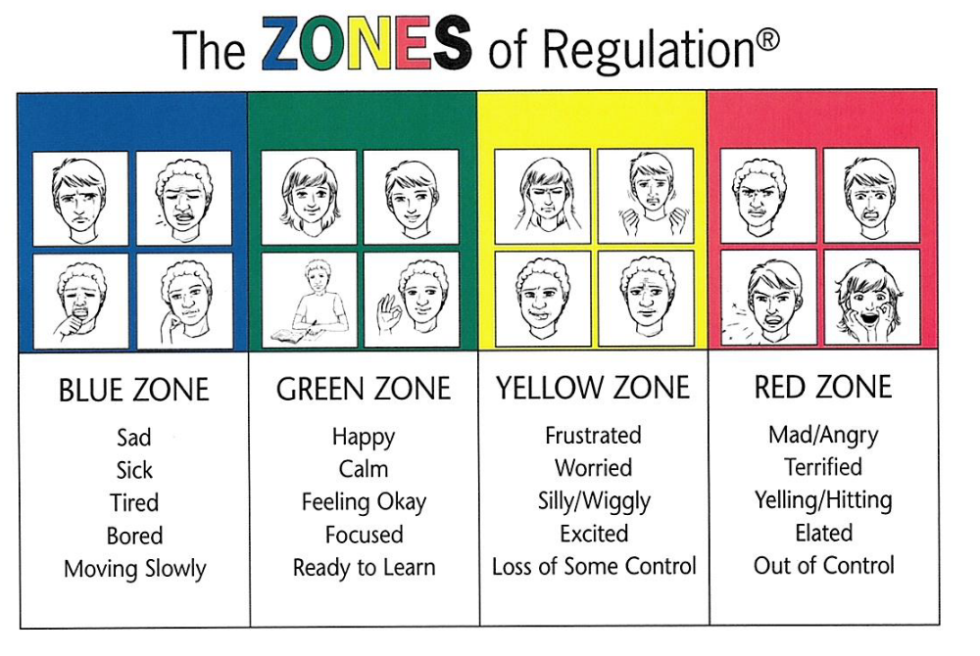

Pyramid of Support

Tier 3

Individual Behaviour Plan
District Student Services
Continued Student Services
Outside Agency Involvement

Tier 2

STEP 4 – Student Services involvement. Meeting with parents, teachers (possibly student). Review behaviour expectations/set up consequences. Guidance is involved to make a behaviour plan.

STEP 3 – Visit to the office. Teacher and student visits with Admin. to review all that has been done in Tier 1. Admin. Phones home and a verbal plan is discussed.

Tier 1

STEP 2 – Teacher – directed with support. Phone calls home, more teacher tutorials, continual reminders and practicing correct behaviour.

STEP 1 – Teacher – directed. Phone calls home, teacher tutorial, remind student of expectations and ask student to practice correct behaviour.

Positive Behaviour Intervention Program (PBIS)

Lincoln Elementary Community School has adopted the philosophy of Positive Behaviour Intervention Program.
It is important to note that most behaviours will be handled according to the pyramid, however there may be exceptions:
- Playground issues will be dealt with on an individual basis.
- Certain behaviours may lead to suspension from school (i.e. fighting, bullying, aggressive behaviour).
- Certain unacceptable classroom behaviours (i.e. refusal to do work, defiance, continued disruption of the learning environment) may lead to alternate placement in school.

Communication between home and school is instrumental in helping your child to succeed emotionally, socially, and academically in school. Please feel free to contact your child’s teacher if you have any questions or concerns regarding behaviour that may be impacting your child’s learning.

The staff works hard to create a positive atmosphere in which students can learn. We believe that our students are responsible for their own behavior. Efforts are made to be proactive in terms of student discipline, and we work with parents to take appropriate action when needed.
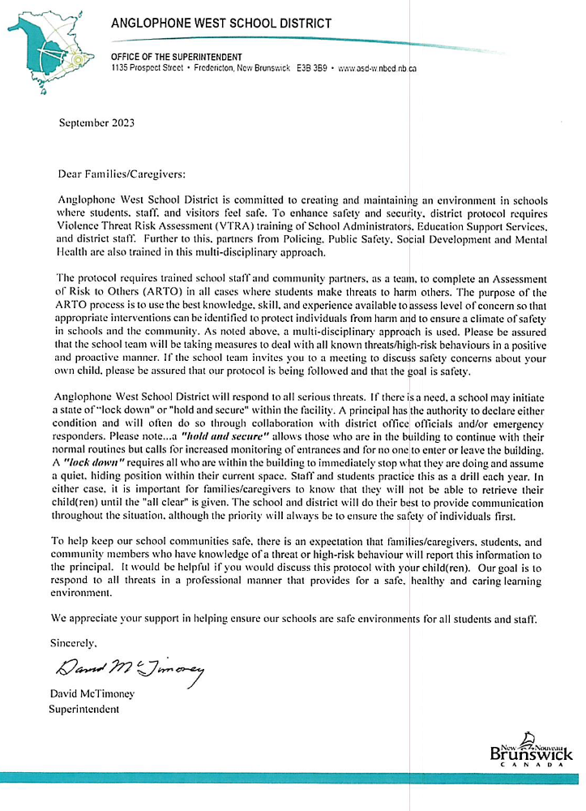

Transportation – 357-4256, 357-4252

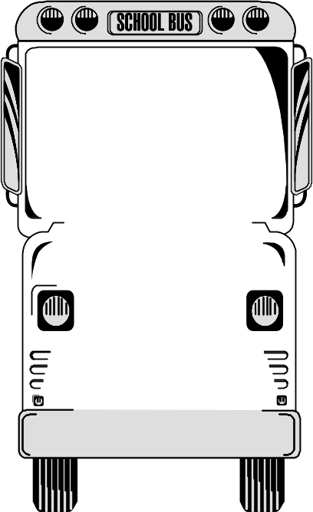

DEPARTMENT OF EDUCATION

SCHOOL BUS SAFETY GUIDELINES
1. Obey the driver promptly.
2. Avoid any unnecessary conversation with the driver while the bus is in motion.
3. Respect the driver and fellow passengers.
- Arrive on time and stand away from the roadway while waiting for the school bus.
- Wait until the bus comes to a complete stop before moving to get on.
- When crossing the road, wait for the driver’s signal and always cross at least 3 metres in front of the bus. NEVER CROSS BEHIND THE BUS.
- Always keep a safe distance around the school bus.
- Go directly to your seat; allow others to sit with you. Remain seated.
- Sit facing forward, with your belongings on your lap or under the seat. Keep the aisle clear.
- Obtain approval of the driver to open windows or emergency door.
Nothing must hang out or be thrown out of the windows of the bus.
- Talk quietly. Silence is required when approaching a railway crossing.
12. Eating and drinking are not allowed on the bus. Use of tobacco is forbidden.
Neither pets nor large objects are allowed on the bus.
- Anyone who intentionally damages the bus will be held responsible.
- Dress according to weather conditions. For safety reasons, avoid drawstrings or loose objects on clothing and backpacks.

PUPIL TRANSPORTATION is a privilege – follow the rules.
VIOLATION may result in disciplinary action and possible loss of the privilege.

SCHOOL POLICIES AND INFORMATION

- Attendance: Regular attendance is stressed. The Schools Act requires a written reason for absence from a parent/guardian. The note should accompany the child on his or her first day back to school, even if you have already notified the school by telephone.

- Appointments with Teachers: As teachers are busy with students or planning for classes during the school day, we ask that you please call or write a note to request a meeting or telephone conversation with your child’s teacher to discuss concerns. Teachers will accommodate you at the first mutually agreed upon time.

- Appointment with Administration: Please contact the school to set up an appointment. We are unable to accommodate impromptu visits.

- Safe Arrival: We remind parents to inform the school of your child’s absence by calling 357-4075 as soon as possible. This information will be forwarded to their classroom teacher.

- Student Arrival:
- Bus students are supervised from the time their bus arrives at school in the morning. Our first bus arrives around 7:40am.

- Supervision begins at 7:40 am daily, with the arrival of the first bus. Students should not be dropped off at school prior to this time as there is no supervision for them.

- Please use the student drop off area in front of the school. You are not permitted to park or drop off in the bus zone. You may be ticketed by the RCMP if you do not abide by this. When you turn into our parking lot, please do not turn right into the loop – this is the bus zone. Only turn left to stop in the student drop off. Please inform family members or friends of this if they are picking your child up for you.

- If your child is dropped off after 8:00 am, please come into the office and sign them in, as they are considered to be late after this time.

- Student Departure: In order to maintain a safe and orderly environment, parents and caregivers are to wait outside until students are dismissed.
If you are picking your child up throughout the school day, you must come to the office area, sign out and wait for them to be called down. Parents are not permitted to go to the classroom to get children during the school day, as this is a disruption to the class.

- Please refer to the “Afternoon Bus Stops Policy” for ASD-W for afterschool travel arrangements.

- If there are last minute (emergency) changes for afterschool, you must contact the school office by 1:00 p.m. This should be kept at a minimum throughout the year.

- Please send a note or phone the school if someone else is picking up your child.

- Bus Passes: Bus passes are no longer issued, according to the new “Afterschool Bus Stops Policy”. Please do not ask us to make exceptions as we will be adhering to the policy. This policy can be found at www.asd-w.nbed.nb.ca

- As an additional safety measure, the doors to our school are locked when the students are in class. The door at the main entrance is also locked during the day. Please ring the doorbell.

- Safety Procedures: A school safety event is a sudden unexpected event which has school or district-wide ramifications affecting the health, safety or social-emotional status of the individual or individuals involved. Each school has a comprehensive school safety plan in place to ensure emergency and crisis response preparedness. Please note: There may be times that schools are in a lock down/secure the building situation. During these types of situations, please do not come to the school expecting to pick up your child. No one will be permitted to enter or exit our building during a lockdown or secure the building. Information will be sent out electronically to parents, as directed by the Superintendent’s office.

- Emergency Contact Numbers: It is extremely important that we have an alternate emergency phone number for your child. This is used when school is cancelled during the day because of weather, as well as in case of sickness or emergency. Emergency contact forms are sent home at the beginning of each school year. IF THERE IS ANY CHANGE OF EMERGENCY CONTACT NUMBERS, PARENTS’ WORK NUMBER OR HOME NUMBERS DURING THE SCHOOL YEAR, PLEASE ENSURE THE SCHOOL IS NOTIFIED. We must be able to reach you at any time in case of emergency!

- School lunch program: With the help of our many energetic volunteers, we will make every effort to have a hot lunch program to offer students. You will be advised of this year’s lunch program once the details have been determined. Please keep in mind, we require reliable volunteers to run this program, otherwise we are unable to have it.

- Please be aware that we do not have microwaves for students and we are not able to heat up lunches for students.

- Allergy Alert: Some students and/or staff at Lincoln Elementary suffer a range of allergy triggers. Products containing nuts are not permitted in school as we have some severe allergy cases. We are a NUT FREE school. We request that you respect our attempts to provide a scent-reduced environment. Smoking is not permitted by Provincial Policy on any school property. If your child suffers from life-threatening allergies please ensure that your child’s teacher is aware of the condition and emergency treatment, and that a medical form, Policy 704, is completed by school staff.

12. Medication: According to District Policy, all prescribed medication must be blister-packed by a pharmacist and delivered to the school office by an adult. A medication form needs to be completed by the parent and signed also by the doctor. It is the parent’s responsibility to fill out the medical form and have it signed by the doctor. Non-prescription medicine may be administered at the school if necessary. A note must accompany this giving the teacher or designate permission to administer. No medication should be given directly to a child for him/her to take without adult supervision.

VOLUNTEERS and P.A.L.S
Volunteers form a very important part of the positive learning environment at our school. A note is sent home at the beginning of the school year to ask for your help as a volunteer. Any time you are able to contribute is appreciated. The P.A.L.S. group (Parents Assisting Lincoln School) plans and organizes the following events: fundraising projects, Halloween party, Fun Nights, etc.

PARENT SCHOOL SUPPORT COMMITTEE (PSSC)
In addition, our Parent School Support Committee is another important volunteer group. The PSSC works in an advisory capacity with the school administration. This committee addresses broad issues related to the education of all children in the school, with the goal of enhancing student learning. Elections for term positions on this committee are held in September of each school year.

We are looking forward to an exciting school year!
It is important that every parent/guardian and student is aware of the information provided in the Student Hand Book. Please ensure that you have read all of the information and please sign Page 9 (VTRA Protocol Awareness) as well as below, indicating that you are aware of the information included in the Hand Book. Thank you!
I have read and I understand the policies and expectations included in the Student Handbook. I have also signed, acknowledging an awareness of the VTRA Protocol.
Parent/Guardian Signature:_____________________Date:___________________

